

**Guidance, Contingencies and Brexit**

Speech given by

Mark Carney, Governor of the Bank of England

Society of Professional Economists 24 May 2018

I am grateful to James Benford and Clare Macallan for their assistance in preparing these remarks.

# Introduction

This evening I would like to discuss potential paths for monetary policy during the next, critical phase of the Brexit process. Note the conditionality of the phrase “potential paths.” The actual path for policy will depend on the outlook for the economy which in turn will depend very much on how the Brexit negotiations evolve.

Monetary policy is always contingent on the economic outlook. This is broader than it being data dependent. In order to achieve the inflation target, monetary policy needs to adjust not only to news about current conditions but also to any changes in likely future circumstances.1 While it may be the MPC that sets interest rates, it is ultimately the economy that determines them.

Monetary policy will be most effective if agents can anticipate how policymakers will react to changing conditions. But the predictability of monetary policy can break down when there are large structural changes in:

* Supply capacity;
* Equilibrium interest rates; or
* Trading relationships.

In such circumstances, forward guidance can help anchor expectations and improve the effectiveness of monetary policy.

This generally wasn’t necessary during the Great Moderation, when the economy was largely subject to a series of demand shocks. The inflation target could be achieved without causing undesirable volatility in output and employment (so-called “divine coincidence”2).

Despite the crisis, divine coincidence has continued to reign in the euro area and the US (see charts in the Appendix). Large output gaps and below-target inflation have pointed monetary policy in the same direction.

That, unfortunately, has not been the case in the UK economy, which has been subject to a series of major supply shocks over the past five years, creating tensions between short-term output and inflation stabilisation. Brexit is the latest and potentially largest example.

Brexit is a regime shift that has markedly increased the range of possible outcomes for the UK economy and therefore the potential paths of monetary policy.

1 Another dimension to uncertainty is ‘model’ uncertainty around the structure of the economy. That is distinct from uncertainty about possible future events, or ‘shocks’, affecting economy. Model uncertainty captures uncertainty around how the economy responds to those events, including to changes in monetary policy itself.

2 See Blanchard, O., and J. Galí (2007). "Real Wage Rigidities and the New Keynesian Model". *Journal of Money, Credit, and Banking*, 39(1), pp. 35-65.

The major Brexit contingencies include:

* The form of the new economic partnership between the EU and UK;
* Whether the transition to that end state will be smooth or cliff-edged; and
* How agents in the economy (households, businesses and financial markets) react to these prospects, particularly the extent to which they are affected by the uncertainty during the negotiations and the degree to which they anticipate the outcome and pull forward adjustment.

As the Brexit process continues and the answers to these questions become clearer, the MPC will adapt its specific guidance and monetary policy more broadly in order to meet the inflation target.

My message this evening is straightforward. From a monetary policy perspective, the Bank of England is ready for Brexit whatever form it takes.

# The role of guidance and the UK experience

Before turning to Brexit, I would like to review briefly the MPC’s experience with forward guidance.

The objective of forward guidance is to give insights into the MPC’s reaction function – in other words, how the Committee will adjust policy when the outlook for growth and inflation changes.

In a perfect world, guidance would be redundant. People would know how the MPC intends to set rates over the future and how those intentions would adjust to economic developments in all eventualities – the

so-called reaction function. But the world is complex and people don’t have endless time to devote to understanding monetary policy. In practice, therefore, guidance can be useful in providing people with information about how the MPC sets policy and, over time, in improving understanding of how monetary policy will adjust to news.

Guidance thus helps people to think along with the Committee so that their expectations about the path of policy adapt with ours as economic circumstances change. This can make monetary policy more effective by reducing unwarranted volatility in interest rate expectations and the extent to which the MPC has to move Bank Rate to meet the inflation target. The more those expectations are aligned with the policy path necessary to achieve the inflation target, the higher the probability that policy objective will be achieved.

Guidance is not a promise of the future path of policy. And its use will not mean that all observers will agree on the likely path of policy for the simple reason that not everyone will agree on the likely path for the economy. However, with guidance, someone who has a different outlook can better anticipate how the MPC will adjust once the scales fall from the Committee’s eyes. Again it is the combination of the economy and the primacy of the inflation target, not the MPC, that ultimately determines that path of policy.

The MPC’s guidance speaks first and foremost to UK households and businesses. This is particularly important during large structural or regime shifts when uncertainty is high. In the wake of financial crises or advance of wholesale changes to trading relationships, people’s expectations for monetary policy can understandably diverge from its most likely path to the detriment of the economy’s performance. Guidance is most useful at such turning points.

The views of economists and financial market participants are, of course, central to the transmission mechanism from Bank Rate, set by the MPC, to the various interest rates facing households and businesses and to asset prices more generally.

Guidance can reinforce the transmission mechanism by reducing unnecessary uncertainty – not eliminating all uncertainty.3 It is not the same as guaranteeing the future stance of monetary policy. Indeed, market participants can be expected to pay the closest attention to any explicit conditionalities around guidance and should usually be the first to update their expectations of policy as the outlook for the economy changes.

Finally, guidance should be seen in the context of a series of MPC initiatives to increase transparency. In recent years, the MPC has made major structural changes to our communications ranging from publishing statements each time we meet to the simultaneous release of Minutes, Inflation Reports and Monetary Policy Summaries on Super Thursdays to the provision of the detailed assumptions underlying our projections. And last year, we introduced layered communications, with simpler, more accessible language and graphics to reach the broadest possible audience.

Crucially, the Committee has also initiated an annual stock take of the supply side of the economy. It now publishes its best collective judgments on the natural rate of unemployment, the output gap, as well as the expected growth in productivity, labour supply and potential output.

To draw out these points consider three examples of forward guidance by the MPC.

The first occurred five years ago when the economy began to recover from the worst downturn since the Great Depression. During previous periods of accelerating growth and firming business confidence, the MPC had always tightened policy significantly (as evidenced in the correlation between survey indicators and MPC votes seen in **Chart 1**). On the basis of this past behaviour, the MPC would have raised interest rates by 2 to 3 percentage points between August 2013 and the end of 2014. For anyone who might suggest the MPC should have followed that reaction function, note that, even on unchanged policy, CPI inflation in the summer of 2016 was running at only about ½% and core CPI inflation around 1¼%.

3 In other words, the amount of volatility in interest rates should match the amount of uncertainty surrounding the economy. There should ideally be no additional volatility, or risk premium, due to uncertainty about how policy would respond.

# Chart 1: Close correlation pre-crisis between output growth and policy

3 month moving average,

3 month moving average,

65 balance 60

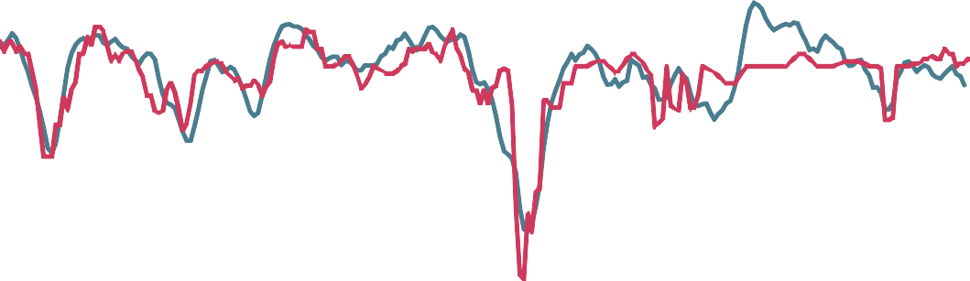

55

50

45

40

Combined CIPS output survey (LHS)

bps

50

25

0

-25

-50

-75

Average MPC vote, including QE

35 (RHS)

30

-100

-125

1998 2000 2002 2004 2006 2008 2010 2012 2014 2016 2018

Sources: IHS Markit, ONS and Bank calculations.

Notes: Combined CIPS output survey is a weighted average of the Markit/CIPS PMIs for services, manufacturing and construction. Average MPC vote includes both decisions on Bank Rate and QE, with every extra £25bn of asset purchases (gilts and corporate bonds) treated as equivalent to a 25bp cut in Bank Rate (see Joyce, Tong and Woods, 2011).

Five years ago, the MPC recognised that past should not be prologue. The MPC was pretty certain there was a large amount of slack, although it had questions over how much productive capacity had been destroyed following the crisis; how quickly productivity growth would recover; and whether labour supply would change in the wake of reforms and a heavy burden of household debt.

Such uncertainties about supply meant that knowing what was happening to demand was no longer sufficient for gauging the appropriate policy response. The historic reduced-form reaction function of the Committee, based on demand alone, would have been a poor guide to the expected path of policy.

That is why the Committee provided forward guidance that explicitly linked any potential change in interest rates to the unemployment rate – a clear and widely understood indicator of the degree of slack.4 The Committee’s objective was to secure the nascent recovery while learning more about the supply capacity of the economy.

The message the Committee gave UK households and businesses was simple: the MPC would not even think about tightening policy at least until the unemployment rate had fallen below 7%, consistent with the creation of around three quarter of a million jobs. We reassured households and businesses that, after five years of decline and stagnation, the recovery would not be choked off prematurely.

That guidance was effective. Surveys conducted in the months that followed indicated high awareness of it among companies, with almost half reporting that they expected Bank Rate to remain at low levels for longer than they would have done were guidance not in place. And the majority said that the Bank’s policy

4 For the full text of the guidance, see the minutes of the August 2013 MPC meeting, available at [https://www.bankofengland.co.uk/minutes/2013/mo](http://www.bankofengland.co.uk/minutes/2013/monetary-policy-committee-august-2013)netar[y-polic](http://www.bankofengland.co.uk/minutes/2013/monetary-policy-committee-august-2013)y-[committee-august-2013](http://www.bankofengland.co.uk/minutes/2013/monetary-policy-committee-august-2013).

guidance had made them more confident about UK economic prospects. Household expectations also shifted markedly in favour of fewer and later rate increases.5 Household and business confidence continued to strengthen, reinforcing the economic momentum.

In the event, the unemployment rate fell far faster than we had expected, falling below 7% in February 2014.

But even as the recovery strengthened and survey indicators of output growth reached levels previously associated with sharp policy tightenings (**Chart 1**), market expectations about the future path of policy remained subdued (**Chart 2**). Participants understood the conditionality of guidance, as they and the MPC learned that there was still considerable spare capacity in the economy.

# Chart 2: Forward market interest rates rose only modestly as unemployment fell quickly towards 7%

August 2013

Data published showing Percent

guidance issued

February 2014 guidance issued

Counterfactual path for Bank Rate based on historic correlation with survey indicators of output growth

UK 1 year instantenous forward OIS rates

unemployment fell to 6.9%

4.0

3.5

3.0

2.5

2.0

1.5

1.0

0.5

0.0

Jan. 12 Jul. 12 Jan. 13 Jul. 13 Jan. 14 Jul. 14

Sources: Bloomberg Finance L.P., IHS Markit, ONS and Bank calculations.

The MPC’s second use of guidance responded to another structural development: the sharp fall in the equilibrium real interest rate, or r*.6

In February 2014, the Committee explained why it expected the equilibrium rate of interest to be much lower than in the past, and then outlined the possible consequences for policy.7

The Committee signalled that the policy path was likely to be different from the past. It observed that the appropriate path of interest rate increases to eliminate slack and keep inflation close to the target was

5 For more information, see the box on page 12 of the February 2014 *Inflation Report*.

6 This is the policy rate that, if allowed to prevail for several years, would keep economic activity at potential and inflation at target.

7 Secular drivers that had pushed down the equilibrium rate prior to the crisis – including slower potential growth, demographic forces, changes in income distribution and excess saving in emerging markets – were likely to persist. Colleagues at the Bank of England estimate that these factors can explain around 400 of the 450 basis points fall in global long-term equilibrium rates since the 1980s (see Rachel, L and Smith, T (2015), “Secular drivers of the global real interest rate”, Bank of England Working Paper No. 571). In addition, more cyclical factors, such as the protracted process of balance sheet repair in both public and private sectors, had weighed further on the equilibrium real rate, causing it to turn sharply negative during the downturn. The MPC expected these forces to fade only gradually as the economy recovered. See Carney, M (2013), “The spirit of the season” at The Economic Club of New York; and the box on page 42 of the August 2014 *Inflation Report*.

expected to be gradual and, even once spare capacity had been absorbed, the appropriate level of Bank Rate was expected to be materially below the pre-crisis average of 5%.

Out of that guidance came the phrase ‘limited and gradual’, so often repeated it has now become part of the monetary policy furniture. Importantly, it is widely recognised by UK households and businesses whose expectations of rate increases have remained well anchored as the recovery has progressed (**Charts 3b and 3c**) as well as by financial markets (**Chart 3a**). Similar guidance was subsequently adopted by the FOMC and ECB.8

# Chart 3: Households and businesses have consistently expected increases in interest rates to be gradual and limited

1. Historic UK Bank Rate tightening cycles

Cumulative change, percentage points

2.0

November 2003

October 1996

September 1994

September 1999

August 2006

May 2018 *Inflation Report*

market interest rate path

November 2017

1.8

1.6

1.4

1.2

1.0

0.8

0.6

0.4

0.2

0.0

Months since first increase in Bank Rate

Sources: Bank of England, Bloomberg Finance L.P. and Bank calculations.

Notes: Tightening cycles since the start of inflation targeting in 1992. Tightening cycles are shown up to when interest rates reached their highest level before they were next reduced. The curve is estimated using instantaneous forward overnight index swap rates in the 15 working days to 2 May 2018.

8 For example, in the minutes of its policy meetings since mid-2014, the FOMC has repeatedly stated that “a gradual approach to raising the target range for the federal funds rate” was judged to be appropriate, while the minutes of the ECB’s policy meetings have noted that “prudence, patience and persistence with regard to monetary policy remained warranted”.

1. Median household Bank Rate expectations

nt 6



Per ce

2014 Q1

2015 Q1

2016 Q1

2017 Q1

2018 Q1

Pre-crisis average level of Bank Rate (5.2%)

5

4

3

2

1

0

0 1 2 3 4 5 6

Years ahead

Notes: Household expectations are from the Bank/TNS Inflation Attitudes survey and show how Bank Rate is expected to increase relative to the rate prevailing at the time. Pre-crisis average Bank Rate is calculated from 1997 to 2007 inclusive.

1. Proportion of households and companies expecting an increase in Bank Rate within the next year

Jan. 2016

EU referendum

July Jan.

2017

July Jan.

2018

Per cent

100

Households

Companies

90

80

70

60

50

40

30

20

10

0

Sources: Deloitte CFO survey and IHS Markit Household Finance Index (HFI).

As intended, “limited and gradual” guidance has dampened interest rate volatility (**Chart 4**) and reduced the correlation between interest rate volatility and economic uncertainty (**Chart 5**).9 Both developments have increased the degree of monetary policy stimulus, thereby reinforcing the recovery during turbulent times.

9 Part of the fall in volatility is likely to be due to rates being close to the lower bound, since this cuts off part of the lower tail of the distribution.

# Chart 4: Interest rate volatility has remained low since guidance was provided

Standard deviation of option-implied distributions for 3m LIBOR in 12-months’ time, UK and US

Basis points

200

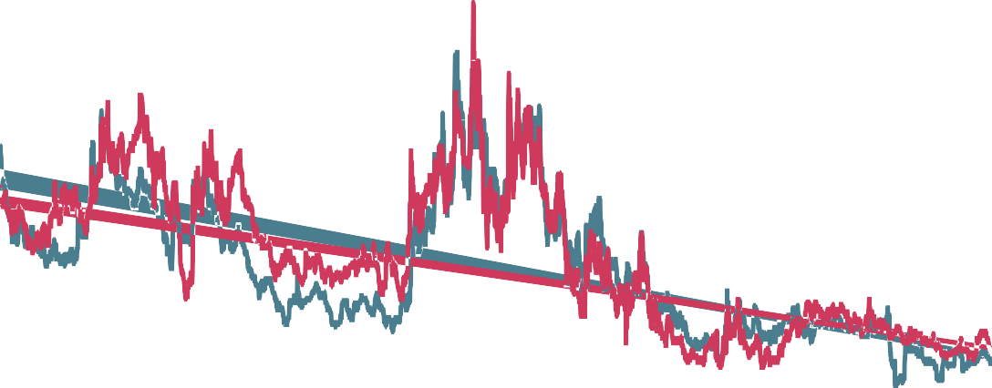

3m US LIBOR (12m ahead) standard deviation

3m UK LIBOR (12m ahead) standard deviation

August 2013 guidance issued

February 2014 guidance issued

EU

referendum

180

160

140

120

100

80

60

40

20

0

2000 2002 2004 2006 2008 2010 2012 2014 2016 2018

Sources: Bloomberg Finance L.P., Chicago Mercantile Exchange (CME), Intercontinental Exchange (ICE) and Bank calculations.

# Chart 5: Guidance has reduced the correlation between economic uncertainty and interest rate volatility

Economic uncertainty10 and option-implied volatility of 3 month rates 1 year ahead

3m rate standard deviation

180



August 2013 - EU referendum

2000-August 2013

EU referendum - latest

160

140

120

100

80

60

40

20

0

-2 -1 0 1 2 3 4 5

Economic uncertainty (deviations from average)

Sources: Bloomberg Finance L.P., ICE, Bank calculations and Haddow *et al*, ibid.

10 The indicator of economic uncertainty is based on the principal component from seven measures of uncertainty: FTSE and sterling option-implied volatility, dispersion of company earnings forecasts and among forecasters’ growth projections, proportion of companies reporting that uncertainty is limiting investment, households’ unemployment expectations, and number of press articles citing ‘economic uncertainty’. See Haddow, A, Hare, C, Hooley, J and Shakir, T (2013) “Macroeconomic uncertainty: what is it, how can we measure it and why does it matter?”, Bank of England Quarterly Bulletin, 2013 Q2.

The MPC is now in the process of reviewing the possible range for the equilibrium real interest rate in the medium term. This analysis reflects the importance of global equilibrium rates for the UK, and the possibilities that the global equilibrium real rate may rise as the global recovery proceeds and that domestic cyclical factors such as the pace of public and private balance sheet repair may shift. The Committee intends to provide information about its updated view in its August *Inflation Report*.

# Guidance, Contingency and Brexit

My third example of guidance is associated with another major structural change: Brexit.

To put the upcoming regime shift into context, consider what has already transpired merely in anticipation of possible future changes to flow of goods, service, capital and people.

On the eve of the referendum, the MPC expected that a vote to leave would prompt the exchange rate to fall sharply, inflation to rise above the 2% target and growth to slow materially.

That is exactly what has happened.

Sterling fell sharply immediately following the result, and remains some 15% below its late-2015 peak before the referendum was called. Financial markets are valuing today what they expect tomorrow: a relative fall in real incomes as the UK moves toward its new trading arrangements.

Inflation rose well above the 2% target, peaking at 3.1% late last year, an overshoot entirely due to the referendum-induced fall in the exchange rate.

And UK growth has dropped from the fastest to the slowest in the G7. The economy has significantly underperformed the MPC’s projections ahead of the referendum, which were conditioned on a vote to remain.11 That deceleration has occurred despite support from a much stronger-than-anticipated euro-area and global growth and much more supportive domestic financial conditions, with the latter importantly influenced by the timely, comprehensive package of easing measures introduced by the Bank’s policy committees after the vote.

The MPC now views the economy’s potential growth rate to be around 1.5%, about 60% of its pre-crisis average. That diminished rate of supply growth reflects the climate of the past few years, with the shallowest investment recovery in over half a century,12 lower growth in labour supply and modest productivity growth.

By the first quarter of this year, UK GDP had increased by 1 percentage point less than the MPC had projected in May 2016. Factoring in the stronger-than-anticipated growth in the European and global economies and more supportive fiscal policy, the shortfall increases to around 1¾%-2%.

11 This was in line with the MPC’s standard approach to condition its projections on the government policy of the time.

12 By contrast, growth in UK total investment outperformed the rest of the G7 in 2017. That reflected strong growth in spending on buildings. Dwellings investment (1.7pp) and spending on other buildings and structures (2.1pp) together contributed 3.8pp to total growth of 4.0%.

Even without taking those additional factors into account, average household incomes are currently 4% lower than the MPC had expected prior to the referendum, equivalent to over £900 per household.13

***Lambda: trade-off management in exceptional circumstances***

The MPC has repeatedly emphasised that monetary policy cannot prevent either the necessary real adjustment as the UK moves to its new trading arrangements or the weaker real income growth likely to accompany that adjustment. Monetary policy can, however, support the economy during the adjustment process.

During these exceptional circumstances, the MPC is required by its remit to balance the trade-off between the speed at which inflation is returned to target and the support that monetary policy provides to jobs and activity.14

The MPC set out our framework for managing this trade-off including guidance on its tolerance for the overshoot of inflation of target under exceptional circumstances.

**Chart 6** illustrates the MPC’s framework for setting policy to manage this trade-off. The red lines represent the potential trade-offs that the Committee could strike: mapping the size of the inflation overshoot that it could be prepared to tolerate for a given amount of spare capacity, and vice versa. The flatter the line, the less weight the Committee places on output stabilisation and the more it is willing to tolerate large output gaps in order to eliminate small overshoots in inflation.

**Chart 6** also demonstrates how the expected trade-off has evolved in successive MPC forecasts since the referendum. It shows the MPC's central projections at Year 2 for CPI inflation on the vertical axis against those for spare capacity (the opposite of excess demand) on the horizontal axis from successive Inflation Reports since August 2016. The projections are conditioned on the market yield curves prevailing at the time the forecasts were made.

Consistent with its remit, the MPC has judged that it has been appropriate to set policy so that inflation returned to its target over a longer period than the conventional horizon of 18-24 months in order to support jobs and activity at a time when uncertainty was elevated and the economy was slowing. It therefore implemented a package of easing measures in August 2016 – shifting the trade-off upwards and to the right

13 One third of the 4% shortfall in real wages reflects stronger-than-projected inflation, which is almost entirely accounted for by the referendum-related fall in sterling. The remainder reflects weaker-than-expected nominal wages, the majority of which can be accounted for by weaker-than-anticipated productivity growth.

14 Specifically, in exceptional circumstances, “shocks to the economy may be particularly large or the effects of shocks may persist over an extended period or both”. When this is the case, the challenge facing the MPC can be more significant, and the remits directs that “[i]n forming and communicating its judgements, the Committee should promote understanding of the trade-offs inherent in setting monetary policy”, including, importantly “the horizon over which the Committee judges it is appropriate to return inflation to the target”.

(from the mauve dot labelled ‘August 2016, no stimulus’ to the purple dot labelled 'August 2016' in

**Chart 6**).15

# Chart 6: MPC has managed the trade-off16

3.0



Inflation (%)

November 2016

August 2016

February 2017

2.5

November 2017

May 2017

August 2017

2.0

February 2018

May 2018

Excess demand (%)

-1.5 -1.0 -0.5 0.0 0.5 1.0 1.5

August 2016,

no stimulus

1.5

Preferred trade-off

if λ=0.1

Preferred trade-off if λ=1

1.0

Since then, the Committee has managed policy to diminish steadily the trade-off, increasing employment, using up the expected degree of spare capacity in the economy, and reducing the expected overshoot of the inflation target.

Throughout this period, inflation expectations have remained well anchored,17 the volatility of interest rates very low, and financial conditions highly supportive.

Over the course of 2017, the steady absorption of slack and the prospect of moving into excess demand by Year 3 – evident in the dots showing the successive Inflation Report projections in **Chart 6** – reduced the degree to which it was appropriate to accommodate an extended period of inflation above the target. As a consequence, the MPC began to remove some of the stimulus policy had been providing raising Bank Rate to ½ percent last November (the pink dot in **Chart 7**).

15 Calculations at the time suggested that returning inflation to target at a conventional horizon could have cost ¼ million jobs and widened the output gap to 1½%. See ‘Lambda’, speech by Mark Carney at the London School of Economics, 16 January 2017.

16 Each observation shows the central projection for spare capacity or excess demand at the end of the second year of the forecast period (the 'Year 2' point) on the horizontal axis against the central projection for four-quarter CPI inflation at Year 2 on the vertical axis from successive *Inflation Reports*. The left-most observation (labelled "Aug. 2016 no stimulus") is a counterfactual version of the August 2016 *Inflation Report* forecasts with the effect of the MPC's Bank Rate cut, Term Funding Scheme and Asset Purchases removed. See ’Lambda’, speech by Mark Carney at the London School of Economics, 16h January 2017, for further details and discussion.

17 See Table 4.C in the May 2018 *Inflation Report*, available at [www.bankofengland.co.uk/inflation-report/2018/may-2018.](http://www.bankofengland.co.uk/inflation-report/2018/may-2018)

**Chart 7: Trade-off in successive *Inflation Report* projections at Year 3**

3.0



Inflation (%)

November 2016

August 2016

2.5

February 2017

May 2017

November 2017

August 2017

2.0

February 2018

May 2018

Excess demand (%)

-1.0

August 2016, no stimulus

-0.5 0.0 0.5 1.0

Preferred trade-off

if λ=0.1

1.5

Preferred trade-off if λ=1

1.0

# A Guidance Stocktake

As the UK enters the most critical phase of the Brexit negotiations, it is useful to take stock of forward guidance and its potential role during the upcoming period.

The interest rate expectations of households and businesses have remained in line with the MPC’s limited and gradual guidance (see **Charts 3b and 3c**).

The MPC’s guidance has anchored expectations in financial markets that interest rates will rise at a gradual pace and to a limited extent (**Chart 3a**).

Guidance has dampened the volatility of interest rates, consistent with the expected and actual path of policy rates (**Chart 4**).

Guidance has reduced the impact of economic uncertainty on short-term interest rates (**Chart 5**).

The responsiveness of market interest rates to economic data has generally been higher in the UK than in the US or euro area (**Chart 8**).

While there have been occasions where financial market expectations diverged somewhat from upcoming MPC decisions, these should be kept in perspective. Divergences have generally been modest moves around the exact timing of a few rate increases over the next few years, as opposed to the launch of the sharp tightening cycles of days gone by (6 to 8 rate increases over 12 to 15 months (**Chart 3**)). Short-term interest rate volatility in the UK has been in line with that in other major economies and is very low relative to history, only in the 5th percentile of its historical distribution since 1997 (**Chart 9**).

Inflation expectations have remained well anchored despite a series of major real and nominal shocks. And financial conditions have remained highly supportive, reinforcing the recovery.

# Chart 8: UK market interest rates still responsive to economic data news

UK

Lehman collapse

Rolling 1-year sensitivity

0.7

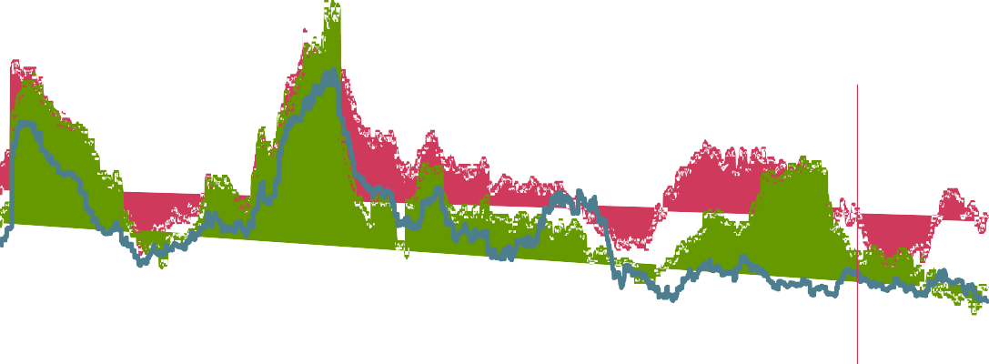

US

Euro area

Draghi "whatever it takes" speech

US presidential election

Eurozone debt crisis

EU referendum

0.6

0.5

0.4

0.3

0.2

0.1

0.0

2004 2006 2008

2010 2012

2014 2016

2018

-0.1

Sources: Bloomberg Finance L.P. and Bank calculations.

Notes: Dotted lines show 2004 – 2017 averages. For details of the methodology, see 'Stirred not shaken: how market interest rates have been reacting to economic data surprises' , Bank Underground blog.

# Chart 9: Interest rate volatility as percentile of historic distribution since 1997

Percentile

0.35

0.30

0.25

0.20

0.15

0.10

0.05

0.00

Jun. 16 Sep. 16 Dec. 16 Mar. 17 Jun. 17 Sep. 17 Dec. 17 Mar. 18

Sources: Bloomberg Finance L.P., ICE and Bank calculations.

# Guidance into Brexit

Now, with the excess supply in the economy virtually used up and the Brexit date looming, monetary policy could travel along two broad paths.

The first path is consistent with the MPC’s current central projection which assumes a smooth transition to a Brexit that is the average of a range of outcomes. In this case, the Committee’s reaction function will become conventional again, with the path of policy driven primarily by demand.

A sharper Brexit could put monetary policy on a different path. For example, if the transition were disorderly, or the end state agreement materially worse than the average potential outcome, then the MPC could once again be confronted by a trade-off between the speed with which it returns inflation to target and the support policy provides to jobs and activity. On this path, the MPC can be expected to set policy to manage any trade-off using the framework it applied following the referendum.

The dependence of policy on which Brexit path is taken is one reason why guidance remains valuable during this crucial phase. Let me expand, beginning with the MPC’s current policy stance.

# The Committee’s latest guidance

The MPC published its latest assessment of the outlook in our May *Inflation Report*. In the MPC’s central forecast, conditioned on the gently rising path of Bank Rate implied by current market yields, GDP is expected to grow by around 1¾% per year on average over the forecast period. While modest by historical standards, the projected pace of GDP growth over the forecast is nonetheless slightly faster than the diminished rate of supply growth, which is projected to average around 1½% per year. Recall that the MPC now publishes all of its key assumptions about supply.

In the MPC’s central projection, a small margin of excess demand emerges by early 2020, feeding through into higher rates of pay growth and domestic cost pressures. Although inflation is projected to fall further over this year as the impact of sterling’s past depreciation continues to wane, building domestic inflationary pressures mean inflation settles at the 2% target around mid-2020.

As the MPC has stressed, were the economy to develop broadly in line with the May *Inflation Report* projections, an ongoing tightening of monetary policy over the forecast period would be appropriate to return inflation sustainably to its target at a conventional horizon.

One simple way to illustrate the potential need for modest rate rises is to look at the Committee’s projection conditioned on a constant rate. In it, excess demand increases to close to 1% of GDP three years from now and inflation is well above target at 2.4% at years 2 and 3 (**Chart 10**).

# Chart 10: With no monetary policy tightening, excess demand builds significantly and inflation remains above target

May 2018 *Inflation Report* projections for inflation and growth

Per cent / Per cent of potential GDP

4.0

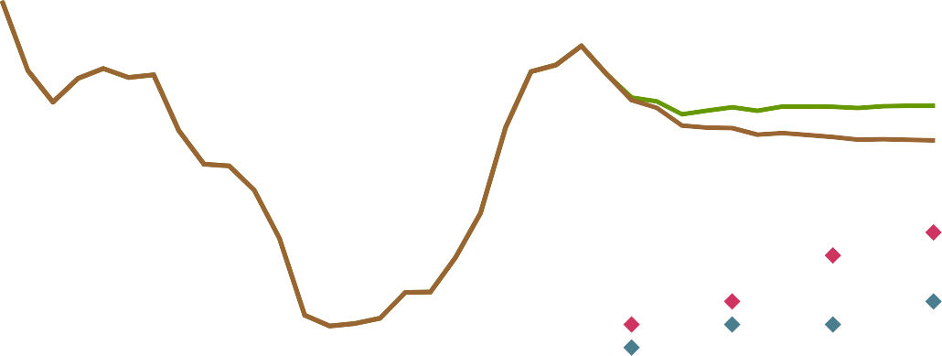

3.5

2% inflation target

Inflation projection - market conditioning path

Excess supply / demand projection

- market conditioning path

Inflation projection - constant rate path

Excess supply / demand projection - constant rate path

3.0

2.5

2.0

1.5

1.0

0.5

0.0

-0.5

-1.0

2012 2013 2014 2015 2016 2017 2018 2019 2020 2021

Of course, as the Committee has made clear before, its guidance about the likely gentle path of rate increases depends on the economy evolving broadly as expected – in particular, whether growth in demand exceeds that of supply.

That might not happen. For example, the weakness in demand at the start of the year could reflect a worsening of the underlying economic climate, not the temporary effects of adverse weather as the Committee currently assesses.

In particular, there is somewhat greater uncertainty about the near-term momentum in consumer spending at present, given recent weakness in consumer credit and the housing market across a range of indicators.

Growth in consumer credit, particularly credit cards, slowed sharply in March. Retail sales volumes have been falling and profit warnings in the retail sector rising. And activity and inflation in the housing market is subdued, despite very low mortgage rates.

The MPC’s projections assume that households will increase their spending broadly in line with their real incomes, as the squeeze following the Brexit vote comes to an end. The bar is relatively low as it implies household spending growth at half its pre-referendum pace and one third of its pre-crisis clip despite record employment and rising real wages.

But there is a risk that households could opt to save rather than spend as their real incomes recover. The more the expectations of households for Brexit resemble those of financial markets and businesses, the more growth is likely to slow below its trend. Excess supply would therefore widen, dampening the expected

increases in domestic inflationary pressures so that inflation falls well below the target (**Chart 11**).18

Monetary policy would be expected to respond.

# Chart 11: Alternative scenarios

1. GDP growth

Percentage changes on a year ago

4.0



3.5

3.0

May 2018 *Inflation Report*

central projection

Stronger investment scenario

Weaker consumption scenario

2.5

2.0

1.5

1.0

0.5

0.0

-0.5

-1.0

2012 2013 2014 2015 2016 2017 2018 2019 2020 2021

1. Inflation

May 2018 *Inflation Report*

Per cent

4.0

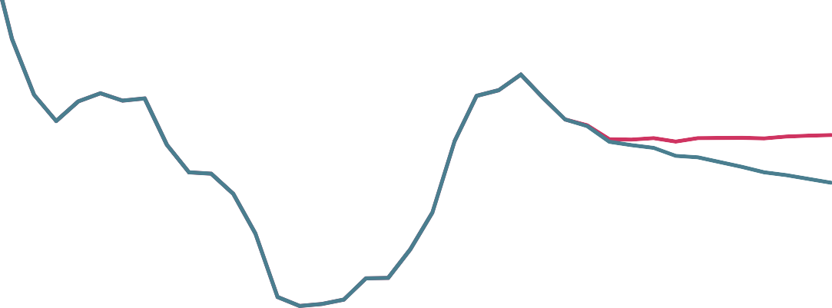

3.5

2% target

central projection

Stronger investment scenario

Weaker consumption scenario

3.0

2.5

2.0

1.5

1.0

0.5

0.0

-0.5

-1.0

2012 2013 2014 2015 2016 2017 2018 2019 2020 2021

18 In this scenario, consumers increase saving rates back towards pre-crisis levels, so that quarterly consumption growth is only around 0% – ¼% compared with ¼% – ½% in the May 2018 *Inflation Report* projections.

1. Excess supply / demand

Projections

|  |  |  |  |  |
| --- | --- | --- | --- | --- |
|  | 2018 Q2 | 2019 Q2 | 2020Q2 | 2021 Q2 |
| May *Inflation Report* central projection | -¼ | 0 | 0 | ¼ |
| Weaker consumption scenario | -¼ | -½ | -¾ | -¾ |
| Stronger investment scenario | -¼ | ¼ | ½ | 1 |

Notes: Per cent of potential GDP. A negative figure implies output is below potential and a positive that it is above

In the opposite direction, growth could surprise on the upside, requiring monetary policy to be tightened by a little more, a little sooner than in the May conditioning path. For example, if business investment growth were to recover much more strongly than currently projected – perhaps because of improved in sentiment about progress on Brexit – then demand would grow well in excess of supply, pushing inflation above target throughout the forecast in the absence of tighter policy.19

These scenarios illustrate how guidance, by revealing the MPC’s reaction function, allows people to anticipate how policy will adapt as the circumstances change.

# The Other Brexit Path

Now consider a different Brexit path where the transition isn’t smooth and/or the final outcome is less open than the MPC’s conditioning assumption.

The Bank is doing all it can to reduce the risks of the former. We are taking steps to reduce financial stability risks around Brexit, just as we did around the referendum when we engaged in extensive contingency planning with HM Treasury, foreign central banks, and private financial institutions.

In particular, the FPC has identified the Brexit “cliff edge” risks and now publishes a quarterly checklist of progress towards their mitigation.

Wherever it can, the Bank is reducing Brexit financial stability risks. For example, our stress test last year encompassed a wide range of UK macroeconomic risks and associated losses that could be associated with Brexit, including a disorderly exit, with UK GDP falling by almost 5%, falls in commercial and residential property prices of over 30%, Bank Rate increasing by 4 percentage points and unemployment rising to 9½%. UK banks were able to withstand that stress and still have more than adequate capital to maintain lending to households and businesses. To be clear, the Bank of England is confident that major UK banks have the balance sheets and liquidity positions to withstand a cliff-edge Brexit.

19 An alternative scenario that would also require a tighter path for policy is weaker supply growth.

For risks that private financial institutions cannot self-solve, the Bank of England is working with HMT to find solutions. For example, the Government has led by committing to put in place if necessary a temporary permission regime to ensure that EU firms can continue their activities in the UK for a limited period after withdrawal.20

And where the issues are cross border, the Bank is working with the ECB to manage risks in the period around Brexit related to financial services, through a new technical working group chaired by President Draghi and myself.

A more disorderly transition, or a materially different end state from our assumption, would have implications for monetary policy. To understand the MPC’s potential response, businesses, households and market participants can draw on the Committee’s track record of managing the trade-off that emerged after the referendum, since exactly the same framework would apply.

As then, the policy response would reflect the balance of the effects of a sharper Brexit on demand, supply and the exchange rate. Given the exceptional circumstances, the Committee would have to decide whether to extend the period over which inflation is returned to target in order to provide support to jobs and activity. Although the exact policy response cannot be predicted in advance, observers know from our track record that, in exceptional circumstances, we are both willing to tolerate some deviation of inflation from target for a limited period of time and that there are limits to that tolerance.

# Conclusion

In recent years, the UK has faced a series of supply shocks and regime shifts that have created a series of difficult trade-offs for monetary policy. Brexit is the most recent and potentially the most important of these. It will soon be entering a critical phase.

The paths that the economy, and monetary policy, could take from here are connected by the expectations of households, businesses and financial markets.

Since the referendum was called, these have reacted at different speeds and to varying degrees to the prospects for the UK’s departure from the EU.

Financial markets, particularly sterling, moved quickly and sharply. Bank analysis suggests that Brexit remains the most important driver of short term market interest rates since then (**Chart 12**).

20 See the written statement to Parliament made by the Chancellor on 20 December 2017, available at [www.parliament.uk/](http://www.parliament.uk/) business/publications/written-questions-answers-statements/written-statement/Commons/2017-12-20/HCWS382/.

# Chart 12: Brexit news has been the main driver of UK interest rates

Decomposition of the variance of UK 3-year interest rates since November 2015

Per cent

100 Other



90 Brexit

80 Euo-area data

70 US data

60 UK data

50 Euro-area monetary policy

40 US monetary policy

30 UK monetary policy

20

10

0

Sources: Bloomberg Finance L.P. and Bank calculations.

Notes: This decomposition is based on changes in UK 3-year interest rates in 30 minute windows around data releases and monetary policy announcements in the UK, US and euro area, and news about Brexit.

Households looked through Brexit-related uncertainties initially. But as the consequences of sterling’s fall showed up in the shops and squeezed their real incomes, they have cut back spending growth to rates about one half of those pre-referendum.

Businesses have been somewhere in between. Since the referendum, they have invested much less aggressively than usual in response to an otherwise very favourable environment – with global demand growing strongly, limited spare capacity, relatively high rates of return on capital and the low cost of finance – reflecting the drag from Brexit-related uncertainties. Evidence from the Bank’s Decision Maker Panel survey indicates that drag took 3-4% off business investment last year. That effect persists, though it has not intensified.

As the Committee has repeatedly stressed, how the economy evolves will depend on how these expectations change as Brexit progresses.

On the one hand, increased caution could drag on demand.

On the other, if there is progress towards the new, deep and special partnership the government is seeking, a boom in investment and potentially consumption could be unlocked, boosting output.

From a monetary policy perspective, the Bank is ready for Brexit. The MPC is well-prepared for whichever path the economy takes. We have the tools we need. We will be prudent not passive. We will respond to

any change in the outlook in these exceptional circumstances to bring inflation sustainably back to target while supporting jobs and activity, consistent with our remit.

Our guidance means that those who follow us will be better able to anticipate our actions. It will make those actions more powerful. And it will help households and businesses consume, save, hire and invest with confidence as the UK determines its path forward.

Thank you.

# Appendix

Frequently, the economy experiences shocks that drive inflation and output in the same direction. These shocks to aggregate demand can include variations in government consumption, households’ desire to consume, or business’ desire to invest. Increases in demand put pressure on the use of resources, causing prices to rise. Because monetary policy can also influence demand it can lean against such shocks. If successful, it can stabilise inflation. In this case, no output-inflation trade-off arises. This is the so-called “divine coincidence”.

Things are different when shocks drive inflation up or down independently of demand. Exogenous changes in firms’ pricing power are one example – so-called cost-push shocks. Shocks to the exchange rate, the economy’s supply capacity, or commodity prices also have this flavour. Because monetary policy’s influence on inflation is predominantly an indirect one, via demand, in such circumstances inflation can only be controlled by delivering an opposing movement in aggregate spending. If something pushes up on inflation directly, monetary policy can only bring inflation back down by causing a reduction in spending via higher interest rates. The speed with which this adjustment is delivered is determined by the monetary policy maker guided by their remit.

Such circumstances have characterised the period in the UK since the global financial crisis (**Chart A1**), which entailed a large adjustment to the supply side of the economy, meaning a lower exchange rate, lower growth, and higher inflation.

In contrast, the US and the euro area have seldom faced a trade-off between output and inflation stabilisation, even since the global financial crisis (**Charts A2 and A3**).

# Chart A: Divine coincidence has continued to reign in the euro area and US post-crisis but not the UK

A1) UK



Great moderation

Financial crisis and after

6 Inflation (%)

*Inflationary, with trade-off*

4

*Inflationary, no*

*trade-off*

2

-6

-5

-4

-3

-2

-1

0

1

2

3

4

Excess demand (%)

0

*Disinflationary, no trade-off*

*Disinflationary, with*

*trade-off*

-2

Sources: ONS and Bank calculations.

A2) US



Great moderation

Financial crisis and after

6 Inflation (%) 5

4

3

2

-8 -7 -6 -5 -4 -3 -2 -1 0 1 2 3 4

1

Excess demand (%)

0

-1

-2

Sources: Bureau of Economic Analysis, CBO and Bank calculations.

Notes: The measure of inflation is the four-quarter change in the personal consumption expenditures (PCE) deflator. The output gap is calculated using the CBO estimate of potential output.

A3) Euro-area



Great moderation

5 Inflation (%)

Financial crisis and after

4

3

8

2

-4

-3

-2

-1

0

1

2

3

4

1

Excess demand (%)

0

-1

Sources: Eurostat, IMF and Bank calculations.

Notes: The measure of inflation is the four-quarter change in the harmonised index of consumer prices (HICP). The output gap is the IMF’s estimate from the October 2016 WEO at an annual frequency, interpolated to create a quarterly series.